Low Level Design (UPDATE COMPOSER MODULE)

Project Code | Team6
Project Name | Media Composer and Artist Management System

Prepared/Modified by | Role | Date of Preparation
Raunak Agarwal | Senior Software Engineer | 13/11/2017
Reviewed by | Role | Date of Review
Vaishali Srivastava | Analyst | 14/11/2017
Approved by | Role | Date of Approval
Vishal Mali | Senior Analyst
Circulation List | raunak.agarwal@capgemini.com  shubham.ayush@capgemini.com  saptarshi.saha@capgemini.com  pratik.sahoo@capgemini.com  vaishali.srivastava@capgemini.com  vishal.mali@capgemini.com | Version Number of the template:1.0
Version Number | 1.3

Table of Contents

1. Description Of The Unit 3
2. References 4
3. Dependencies / Assumptions 5
4. Class Diagrams 6
5. Sequence Diagrams 7
6. Design Components 8
6.1 List Of UI Components 8
6.2 List Of Design Classes 8
7. Re-Usable Routines/Components 9
8. Messages 10
9. Configuration Files 11
10. Crud Matrix Table 12
11. Data Mapping Matrix 13
12. Action Flow Matrix 14
13. Stored Procedures 15
14. Program Specification / Pseudo Code 16
REVISION HISTORY OF THE WORK PRODUCT 17

Description Of The Unit

The Update module is basically used by the administrator of the system, to update the existing composer. It requires a pre-requisite that the administrator should be logged into the system.

On clicking the modify button on the show composer page where he selects a composer to be updated, the admin will be redirected to the modify composer page. Once the composer is chosen for updating, previously existing details about that composer which are brought from the database are displayed in the text fields. The admin can then modify desired fields and then update the changes in the database. Modified fields are first validated, if valid the details are updated into the database and the admin is redirected to the success page or else if the entered details are invalid an appropriate error message is displayed.

References

Reference | Description
Repository reference | https://github.com/pratik77/plp
Class Diagram | /Project Documents/Design Documents/HLD/Class Diagrams
URS | /Project Documents/Requirements/Case Study/Media.doc
UTP | Project Documents/Test Plan/UTP/Test Cases/ UpdateComposer/ UTP_UpdateComposerModule.xls
DB Design | /Project Documents/Design Documents/HLD/DB Design/MediaComposerSystem_Group6_DBDESIGN.xls

Dependencies / Assumptions

Dependencies:
Update module depends on the Login module in such a way that, the admin is able to update a composer only when he is logged in.

Class Diagrams

Class Diagram

Sequence Diagrams

Sequence Diagram
NA

Design Components

List Of UI Components

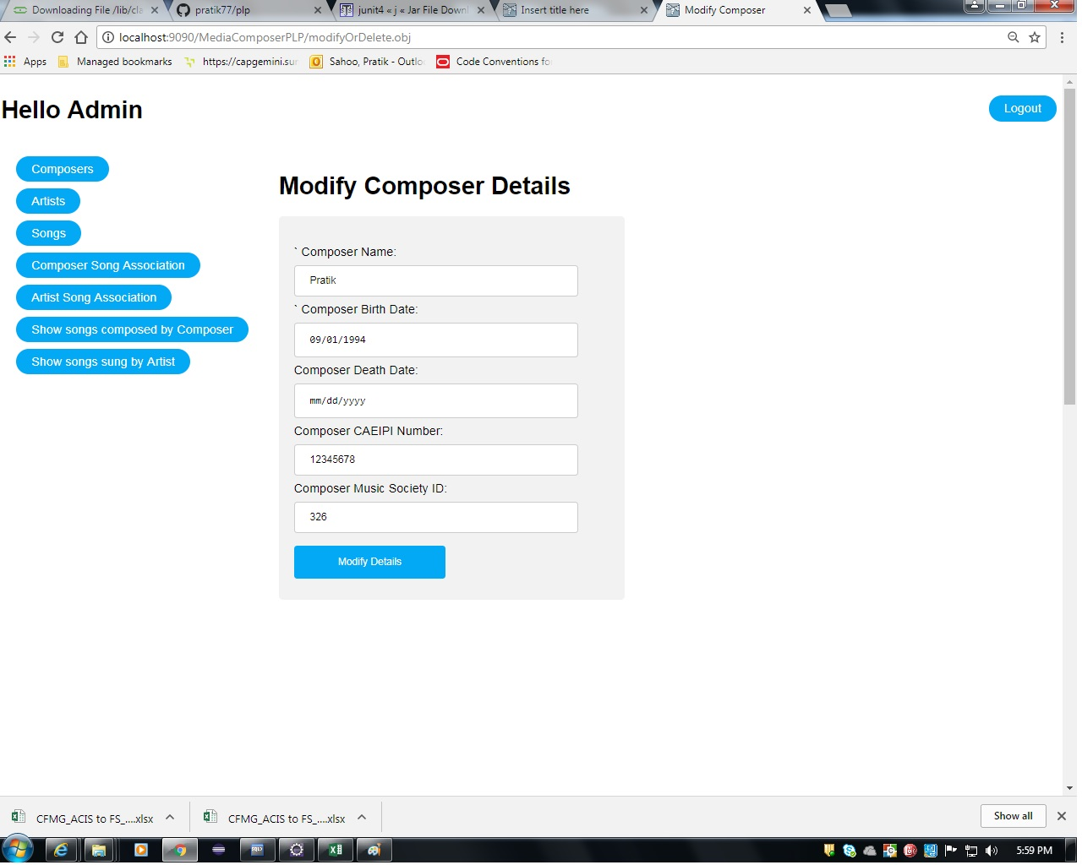

List Of Design Classes
Sr. No. | LLD Name | Class Name | Method Name | Method Description
1 | Update Module | ComposerMasterDTO | Appropriate getters and setters methods | Getters retrieve the property values and setters set the property values
2 | Update Module | MediaController | modifyAndDeleteComposer(@RequestParam("submit") String submit, @RequestParam("composerId") String composerId, @ModelAttribute("composerMasterDTO") ComposerMasterDTO composerMasterDTO, Model model): String  modifyComposer(@ModelAttribute("composerMasterDTO") ComposerMasterDTO composerMasterDTO,Model model) :String | Sets the model attribute.  Calls getComposerById (composerId) of MediaServiceImpl class. It basically fetches details of existing composer as composer object and sets it into session , then it redirects to update page else in case of exception redirects to error page with appropriate error message.  Calls updateComposer(ComposerMasterDTO composerMasterDTO) of MediaServiceImpl class. If it returns true then it redirects to update page with a span message else it redirects to error page with appropriate error message.
3 | Update Module | MediaServiceImpl | getComposerById(int composerId):ComposerMasterDTO  updateComposer(ComposerMasterDTO composerMasterDTO): ComposerMasterDTO | Calls getComposerById(int) of MediaDAOImpl class and returns the result to controller.  Calls updateComposer ( ComposerMasterDTO ) of MediaDAOImpl class and returns the result to controller.

4 | Update Module | MediaDAOImpl | getComposerById(int composerId):ComposerMasterDTO  updateComposer(ComposerMasterDTO composerMasterDTO): ComposerMasterDTO | Gets the details of the desired composer depending upon the composer Id from database and returns Composer result to MediaServiceImpl.  Update the desired composer into the database and returns result to MediaServiceImpl .

Re-Usable Routines/Components

Re-Usable Routines/Components

- CSS files
- Javascript files
- DataAccessException class
- Database properties files
- Logger properties files

Messages

#. | Type | Message Text
M1 | Error | Please fill out this field (if empty)
M2 | Error | Please fill out this field (if empty)
M3 | Error | Died date should be before Born Date
M4 | Error | CAEIPI Number should be 7 to 10 digits
M5 | Error | Music Society Id should be of 3 characters

Configuration Files

File Name | Path | Description
oracle.properties | /Development/Source | To configure database connection.
Web.xml | /Development/Source | To configure the bean properties.
Dispatcher-servlet.xml | /Development/Source | To configure the request mapping and view resolver.
logger.properties | /Development/Source | To configure the logger.
error.properties | /Development/Source | To configure error messages.
JPAContext.xml | /Development/Source | To configure the datasource, entity manager factory and transaction manager.

Crud Matrix Table

# | Table Name | Create | Read | Update | Delete
1 | Composer_Master | N | Y | Y | N

Data Mapping Matrix

Sr. No. | Screen Label | Field Source | Field Type | Data Type | Max Length | Data Flow | Mandatory
1 | Composer Name | NA | Label | NA | NA | UI | NA
2 | composerName | ComposerMasterDTO.  Composer_Name | TextBox | Varchar2 | 50 | UI→D | Yes
3 | Composer Born Date | NA | Label | NA | NA | UI | NA
4 | composerBornDate | ComposerMasterDTO. Composer_BornDate | Date | Date | NA | UI→D | Yes
5 | Composer Died Date | NA | Label | NA | NA | D→UI | NA
6 | composerDiedDate | ComposerMasterDTO. Composer_DiedDate | Date | Date | NA | UI→D | Yes
7 | Composer Caeipi Number | NA | Label | NA | NA | UI | NA
8 | composerCaeipiNumber | ComposerMasterDTO. CaeipiNumber | TextBox | Varchar2 | 10 | UI→D | Yes
9 | Composer Music Id | NA | Label | NA | NA | UI | NA
10 | composerMusicSocId | ComposerMasterDTO. MusicSocietyId | TextBox | Char | 3 | UI→D | Yes
11 | Modify Composer | NA | Submit | NA | NA | UI | NA

Legend
D → UI (Database to User Interface)
UI → D (User Interface to Database)
UI (User Interface Only)

Action Flow Matrix

Sr. No. | Action | Description | Process
1 | On click of Modify button for a particular composer on home screen | Admin is navigated to composer description page | When admin clicks on update button if one particular composer he is navigated to description page where he can modify desired fields related to that composer.
2 | On click of Update Composer button in Composer Description page. | Admin is notified about the updation of composer. | On clicking update composer button, the modified values of the composer attributes are updated into the database.

Stored Procedures

# | Stored Procedure Name  (with Description) | Input/Out Parameters | Type | Size
1. | N/A | N/A | N/A | N/A

Program Specification / Pseudo Code

<ACTION: MODIFY_CLICK >

Pseudo Code:
- Client Side Scripting:
None

- Server Side Scripting:
BEGIN
Call modifyAndDeleteComposer(@RequestParam("submit") String submit, @RequestParam("composerId") String composerId,@ModelAttribute("composerMasterDTO") ComposerMasterDTO composerMasterDTO, Model model) in Controller class
BEGIN
Call getComposerById() from MediaServiceInterface of service layer
BEGIN
Call getComposerById() in MediaDAOInterface of dao layer.
BEGIN
Create query for retrieving composer details list from Composer_Master table
Return Composer
END
Return Composer to service layer.
END
Return Composer to presentation layer.
END
Navigate to update composer page
END

14. 2 <ACTION: UPDATE_PRODUCT_CLICK>

Pseudo Code:

- Client Side Scripting:

IF ComposerName is Empty
Print Error Message M1
IF ComposerBornDate is Empty
Print Error Message M2
IF invalid ComposerBornDate
Print Error Message M3
IF invalid ComposerCAEIPINumber
Print Error Message M4
IF invalid ComposerMusicSocietyId
Print Error Message M5

<ACTION: UPDATE_CLICK >

Pseudo Code:
1. Client Side Scripting:
None

- Server Side Scripting:

BEGIN
Call modifyComposer(@ModelAttribute("composerMasterDTO") ComposerMasterDTO composerMasterDTO, Model model) in Controller class in presentation layer.
BEGIN
Call updateComposer(ComposerMasterDTO) in
MediaServiceImpl class in Service Layer
BEGIN
Call updateComposer(ComposerMasterDTO) in
MediaDAOImpl class in Layer

BEGIN
Create query for updating composer details into Composer table
END
Return Composer to Service Layer
END
Return Composer to Presentation Layer
END
Navigate to success screen page
END

REVISION HISTORY OF THE WORK PRODUCT

# | Date | Version # | Section Changed | Details of changes made | Approved By
1 | 13/11/2017 | 1.0 | LLD prepared | N/A | Vishal Mali
2 | 05/11/2017 | 1.1 | Reusable components,  Pseudo code | Reusable components added.  The pseudo code is modified as per the specified flow. | Vishal Mali
3 | 08/11/2017 | 1.2 | Reusable components,  References,  Data Mapping Matrix. | Reusable Components added.  File name with relative path is added in the references section.  The name of text boxes(screen label is changed). | Vishal Mali
4 | 09/11/2017 | 1.3 | Configuration files,UI Components | Paths of the configuration files is updated and UI components(Screen Shots) added. | Vishal Mali

